**School Uniform: SHOES**

[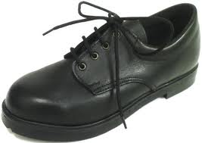](http://www.google.com.au/imgres?q=black+school+shoes&um=1&hl=en&safe=active&sa=N&biw=1366&bih=587&tbm=isch&tbnid=UGAis6ouFa3MUM:&imgrefurl=http://www.bilbyshoes.com/page13.html&docid=hHpoJcQXevdTvM&imgurl=http://www.bilbyshoes.com/attachments/Image/wallaby_black.jpg&w=447&h=316&ei=CgWrUOe5LO6imQWtxYCYCQ&zoom=1&iact=hc&vpx=373&vpy=280&dur=5585&hovh=189&hovw=267&tx=142&ty=167&sig=100718891362253927631&page=2&tbnh=123&tbnw=174&start=23&ndsp=29&ved=1t:429,r:9,s:23,i:175)[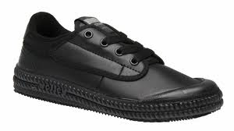](http://www.google.com.au/imgres?q=black+leather+school+shoes&start=102&um=1&hl=en&safe=active&sa=N&tbo=d&biw=1311&bih=564&tbm=isch&tbnid=dLxZiMXDH0X2sM:&imgrefurl=http://www.ebay.com.au/itm/DUNLOP-VOLLEY-INTERNATIONAL-LEATHER-KIDS-SHOES-BLACK-AUS-SIZES-/400259919225&docid=SHDfwf7KexkTYM&imgurl=http://i.imgur.com/QPXQK.jpg&w=600&h=337&ei=pxO0UMzAOqnYigeT6oDYAw&zoom=1&iact=hc&vpx=612&vpy=261&dur=10572&hovh=168&hovw=300&tx=128&ty=125&sig=100718891362253927631&page=6&tbnh=122&tbnw=217&ndsp=18&ved=1t:429,r:9,s:102,i:92)[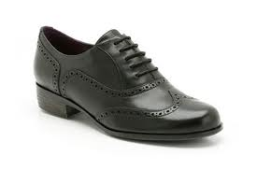](http://www.google.com.au/imgres?q=black+leather+school+shoes&start=317&um=1&hl=en&safe=active&biw=1366&bih=587&tbm=isch&tbnid=LSHKqdlnErgtVM:&imgrefurl=http://www.kcmode.com/clarks-shoes---womens-clarks-hamble-oak-black-leather-work-school-shoes-22179-p.asp&docid=dzz5NxCgNCurgM&imgurl=http://www.kcmode.com/ekmps/shops/kcmodeltd/images/clarks-shoes-womens-clarks-hamble-oak-black-leather-work-school-shoes-22179-p.jpg&w=420&h=280&ei=HQirULu-B6fcmAWWiIGQDw&zoom=1&iact=hc&vpx=892&vpy=266&dur=1638&hovh=183&hovw=275&tx=160&ty=107&sig=100718891362253927631&page=12&tbnh=116&tbnw=159&ndsp=30&ved=1t:429,r:13,s:317,i:135)[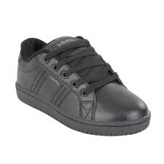](http://www.google.com.au/imgres?q=black+leather+school+shoes&start=137&um=1&hl=en&safe=active&biw=1366&bih=587&tbm=isch&tbnid=8SO7Klb25Qf4-M:&imgrefurl=http://www.paylessshoes.com.au/products/school-senior-b/oliver-boys&docid=8pjx7JuC_ENltM&imgurl=http://www.paylessshoes.com.au/sb_cache/products1/id/7334/f/Oliver_Youths.jpg&w=600&h=600&ei=xgerUMTkGvGKmQX3woHQDg&zoom=1&iact=hc&vpx=501&vpy=243&dur=2091&hovh=225&hovw=225&tx=123&ty=128&sig=100718891362253927631&page=6&tbnh=134&tbnw=148&ndsp=28&ved=1t:429,r:10,s:137,i:218)[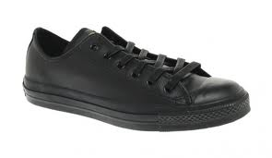](http://www.google.com.au/imgres?q=converse+black+leather+shoes&um=1&hl=en&safe=active&sa=N&tbo=d&biw=1311&bih=564&tbm=isch&tbnid=LnR-dpXIJnHiuM:&imgrefurl=http://theshoebuff.com/news/converse-black-leather-lo-allstar/&docid=L3g8r1UvCfxOBM&imgurl=http://theshoebuff.com/wp-content/uploads/2010/10/Converse-Black-Leather-Lo-All-Star-1.jpg&w=600&h=347&ei=0pS-UNvCFK6aiAe1h4DIDA&zoom=1&iact=hc&vpx=262&vpy=275&dur=1841&hovh=171&hovw=295&tx=133&ty=121&sig=100718891362253927631&page=1&tbnh=111&tbnw=170&start=0&ndsp=25&ved=1t:429,r:19,s:0,i:144)Shoes that comply with the school uniform code must be ⮚ covered ⮚ black ⮚ leather ⮚ black laces. Examples of shoes that comply with the school uniform code are pictured below:

✓

✓

[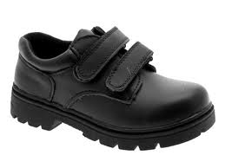](http://www.google.com.au/imgres?q=black+school+shoes&um=1&hl=en&safe=active&sa=N&biw=1366&bih=587&tbm=isch&tbnid=ZQSLA-F-f_FxiM:&imgrefurl=http://www.ebay.com.au/itm/KIDS-BOYS-BLACK-LEATHER-SCHOOL-SHOES-VELCRO-SIZE-9-13-/160626331127&docid=t-rG3Jp6SGKiLM&imgurl=http://images.esellerpro.com/2355/I/176/77/513.jpg&w=400&h=300&ei=CgWrUOe5LO6imQWtxYCYCQ&zoom=1&iact=hc&vpx=700&vpy=247&dur=983&hovh=194&hovw=259&tx=175&ty=107&sig=100718891362253927631&page=2&tbnh=126&tbnw=185&start=23&ndsp=29&ved=1t:429,r:26,s:23,i:228)[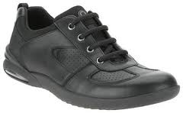](http://www.google.com.au/imgres?q=black+leather+school+shoes&um=1&hl=en&safe=active&biw=1366&bih=587&tbm=isch&tbnid=quJXAIbJnK3mhM:&imgrefurl=http://www.ebay.com.au/itm/290661863398&docid=Qvg5ovxzhYkDoM&itg=1&imgurl=http://i.ebayimg.com/00/s/NDY3WDc1MA==/$(KGrHqV,!nkE8VSKi6H(BPH2zFJ2tg~~60_35.JPG&w=300&h=186&ei=tQerUMzZC8H1mAWjooD4Aw&zoom=1&iact=hc&vpx=1035&vpy=171&dur=2090&hovh=148&hovw=240&tx=148&ty=91&sig=100718891362253927631&page=3&tbnh=104&tbnw=168&start=53&ndsp=27&ved=1t:429,r:19,s:53,i:297)

✓

✓

[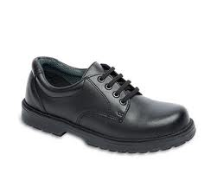](http://www.google.com.au/imgres?q=black+school+shoes&um=1&hl=en&safe=active&sa=N&biw=1366&bih=587&tbm=isch&tbnid=fdrRBY6-Ee4yjM:&imgrefurl=http://live.longhill.org.uk/?p=3835&docid=VAEzkadHViiX_M&imgurl=http://live.longhill.org.uk/wp-content/uploads/2012/02/Black-Shoes.jpg?ab5ade&w=500&h=400&ei=CgWrUOe5LO6imQWtxYCYCQ&zoom=1&iact=hc&vpx=85&vpy=284&dur=1654&hovh=201&hovw=251&tx=145&ty=161&sig=100718891362253927631&page=1&tbnh=121&tbnw=144&start=0&ndsp=23&ved=1t:429,r:15,s:0,i:117)

[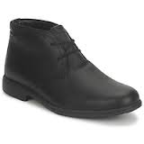](http://www.google.com.au/imgres?q=black+leather+school+shoes&start=235&um=1&hl=en&safe=active&sa=N&tbo=d&biw=1311&bih=564&tbm=isch&tbnid=bGlq61q3oCj9HM:&imgrefurl=http://www.ciao.co.uk/Fashion_Accessories_5302023_2-fashion_for-men,brand-clarks&docid=8bDAx9Ybhz1hUM&imgurl=http://uk-can1.ciao.com/can_uk/12216646734.jpg&w=200&h=200&ei=GRS0UIjxGqmTiQeM0oGwAw&zoom=1&iact=hc&vpx=494&vpy=189&dur=708&hovh=160&hovw=160&tx=71&ty=97&sig=100718891362253927631&page=13&tbnh=160&tbnw=160&ndsp=19&ved=1t:429,r:3,s:235,i:134)

[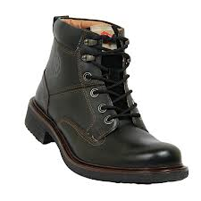](http://www.google.com.au/imgres?q=black+shoes&start=122&um=1&hl=en&safe=active&tbo=d&biw=1311&bih=564&tbm=isch&tbnid=dfy6G8rAU9hX_M:&imgrefurl=http://www.bagittoday.com/Lee-Cooper-Shoes---LC9578-Black/Deals/17375.htm&docid=o7KLL28N1OuSeM&imgurl=http://images.bagittoday.intoday.in/images/itbc/companies/99/prioducts/17375/Lee-Cooper-Shoes---LC9578-Black-01.jpg&w=900&h=900&ei=aha0UI6QJMaZiAfTz4DAAw&zoom=1&iact=rc&dur=1&sig=100718891362253927631&page=7&tbnh=184&tbnw=193&ndsp=19&ved=1t:429,r:12,s:122,i:162&tx=120&ty=159)

✓

[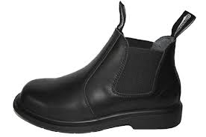](http://www.google.com.au/imgres?q=black+school+shoes&um=1&hl=en&safe=active&sa=N&biw=1366&bih=587&tbm=isch&tbnid=kcJRqiOtV7K1dM:&imgrefurl=http://www.shoes2u.com.au/blundstone_hillwood_kids.html&docid=lCO4imQ0gtjLRM&imgurl=http://www.shoes2u.com.au/images/D/blundstone_hillwood_school_shoe.gif&w=480&h=318&ei=CgWrUOe5LO6imQWtxYCYCQ&zoom=1&iact=hc&vpx=83&vpy=286&dur=1435&hovh=183&hovw=276&tx=185&ty=141&sig=100718891362253927631&page=2&tbnh=109&tbnw=165&start=23&ndsp=29&ved=1t:429,r:15,s:23,i:194)[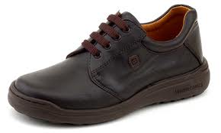](http://www.google.com.au/imgres?q=black+school+shoes&um=1&hl=en&safe=active&sa=N&biw=1366&bih=587&tbm=isch&tbnid=LhVqByip3Viw4M:&imgrefurl=http://www.littlebigshoes.com.au/&docid=U03n5EvgJPvasM&imgurl=http://www.littlebigshoes.com.au/hunterAdmin/uploads/hero-school-shoe.png&w=400&h=240&ei=CgWrUOe5LO6imQWtxYCYCQ&zoom=1&iact=hc&vpx=838&vpy=247&dur=733&hovh=174&hovw=290&tx=134&ty=120&sig=100718891362253927631&page=3&tbnh=99&tbnw=165&start=52&ndsp=27&ved=1t:429,r:5,s:52,i:254)

**Suede is leather.**

**Canvas and cotton are not!**

[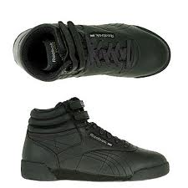](http://www.google.com.au/imgres?q=black+school+shoes&um=1&hl=en&safe=active&sa=N&biw=1366&bih=587&tbm=isch&tbnid=6qa6LnAHzI_tAM:&imgrefurl=http://www.select2gether.com/reebok-kids-freestyle-hi-pre-school-shoes-black&docid=6J_9-DivGBo00M&imgurl=http://www.shoesteal.com/productimages/Shoes_iL37368.jpg&w=325&h=325&ei=CgWrUOe5LO6imQWtxYCYCQ&zoom=1&iact=hc&vpx=738&vpy=244&dur=7488&hovh=225&hovw=225&tx=154&ty=204&sig=100718891362253927631&page=1&tbnh=121&tbnw=116&start=0&ndsp=23&ved=1t:429,r:20,s:0,i:132)[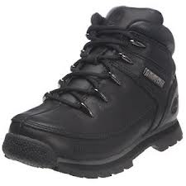](http://www.google.com.au/imgres?q=black+leather+school+shoes&start=518&um=1&hl=en&safe=active&biw=1366&bih=587&tbm=isch&tbnid=i4JJeuDgaIJLmM:&imgrefurl=http://www.sportsmart.co.uk/42987-timberland-splitrock-leather-boots-black-junior-boys-size.html&docid=pKLKnfXoV0nNnM&imgurl=http://images.esellerpro.com/2369/I/426/99/medscale53788.jpg&w=300&h=300&ei=pQirULKyLorLmgW2koGwBg&zoom=1&iact=hc&vpx=466&vpy=229&dur=4212&hovh=225&hovw=225&tx=147&ty=143&sig=100718891362253927631&page=19&tbnh=131&tbnw=137&ndsp=28&ved=1t:429,r:2,s:518,i:101)[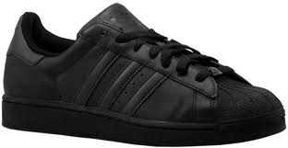](http://www.google.com.au/imgres?q=black+leather+school+shoes&start=179&um=1&hl=en&safe=active&sa=N&tbo=d&biw=1311&bih=564&tbm=isch&tbnid=frlTLS4RJCEmpM:&imgrefurl=http://findnsave.washingtonpost.com/Product/12252703/Nike-Sweet-Classic-Leather-Mens-Sport-Inspired-Shoes-Black-Black-Black&docid=sbKpGbFQiKsgUM&imgurl=http://imagethumbnails.milo.com/010/989/535/trimmed/10989062_23748535_trimmed.jpg&w=774&h=400&ei=pxO0UMzAOqnYigeT6oDYAw&zoom=1&iact=hc&vpx=372&vpy=182&dur=1596&hovh=161&hovw=312&tx=213&ty=113&sig=100718891362253927631&page=10&tbnh=112&tbnw=216&ndsp=19&ved=1t:429,r:2,s:179,i:317)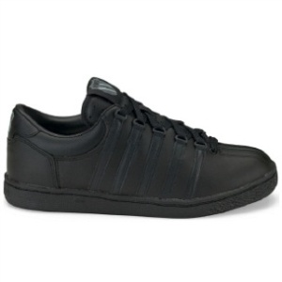

**Shoes that do not comply** with the school uniform code include:

⮚ all non-leather shoes

⮚ shoes with any colour other than black on the upper or the sole or the laces

⮚ shoes that are open on the top exposing a significant proportion of the foot

Examples of shoes that do not comply with the school uniform code are pictured below:

[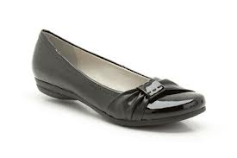](http://www.google.com.au/imgres?q=black+leather+school+shoes&start=347&um=1&hl=en&safe=active&biw=1366&bih=587&tbm=isch&tbnid=gvd-NmygfqvvyM:&imgrefurl=http://www.kcmode.com/clarks-shoes-discovery-bay-black-patent-leather-pump-work-school-shoes-22167-p.asp&docid=EQhV0HNRdRpDkM&imgurl=http://www.kcmode.com/ekmps/shops/kcmodeltd/images/clarks-shoes-discovery-bay-black-patent-leather-pump-work-school-shoes-22167-p.jpg&w=420&h=280&ei=HQirULu-B6fcmAWWiIGQDw&zoom=1&iact=hc&vpx=885&vpy=245&dur=8893&hovh=183&hovw=275&tx=163&ty=111&sig=100718891362253927631&page=13&tbnh=124&tbnw=164&ndsp=28&ved=1t:429,r:12,s:347,i:227)[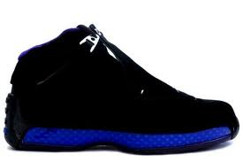](http://www.google.com.au/imgres?q=black+leather+school+shoes&start=860&um=1&hl=en&safe=active&biw=1366&bih=587&tbm=isch&tbnid=RGMFObzngcJ9fM:&imgrefurl=http://www.jordanretro4sale.org/air-jordan-18-retro-c-10.html&docid=gyFJQRIZ7-c2nM&imgurl=http://www.jordanretro4sale.org/images/Air_Jordan_18_Retro_Basketball_Shoes_Black_Leather_Blue_1.jpg&w=600&h=399&ei=RQmrUKfYF4eimQXPvYAg&zoom=1&iact=hc&vpx=850&vpy=155&dur=1029&hovh=183&hovw=275&tx=145&ty=137&sig=100718891362253927631&page=31&tbnh=124&tbnw=187&ndsp=28&ved=1t:429,r:5,s:860,i:297) [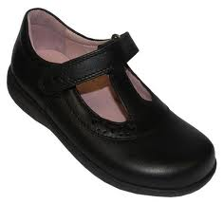](http://www.google.com.au/imgres?q=black+school+shoes&um=1&hl=en&safe=active&sa=N&biw=1366&bih=587&tbm=isch&tbnid=nAMyzmmw16oR1M:&imgrefurl=http://www.raspberrylaces.co.uk/startrite-pre-trinity-school-shoe-black-leather.ir?cName=girls-shoes-school-shoes&docid=QGDuqk9AvC9cpM&imgurl=http://www.raspberrylaces.co.uk/images/_lib/startrite-pre-trinity-school-shoe-black-leather-2465-0-1278672856000.jpg&w=520&h=476&ei=CgWrUOe5LO6imQWtxYCYCQ&zoom=1&iact=hc&vpx=632&vpy=134&dur=3854&hovh=215&hovw=235&tx=136&ty=135&sig=100718891362253927631&page=1&tbnh=128&tbnw=147&start=0&ndsp=23&ved=1t:429,r:4,s:0,i:82) [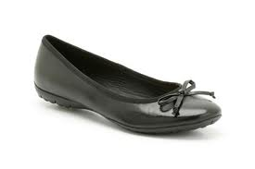](http://www.google.com.au/imgres?q=black+leather+school+shoes&start=140&um=1&hl=en&safe=active&sa=N&tbo=d&biw=1311&bih=564&tbm=isch&tbnid=KwhoHrpW-RsBWM:&imgrefurl=http://www.kcmode.com/clarks-shoes---womens-arizona-heat-black-leather-ballerina-work-school-shoes-15802-p.asp&docid=xvs3Q_NFfM5_MM&imgurl=http://www.kcmode.com/ekmps/shops/kcmodeltd/images/clarks-shoes-womens-arizona-heat-black-leather-ballerina-work-school-shoes-15802-p.jpg&w=420&h=280&ei=pxO0UMzAOqnYigeT6oDYAw&zoom=1&iact=hc&vpx=221&vpy=185&dur=3745&hovh=183&hovw=275&tx=201&ty=132&sig=100718891362253927631&page=8&tbnh=159&tbnw=233&ndsp=20&ved=1t:429,r:8,s:140,i:211)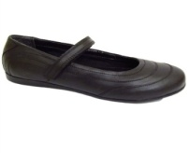

🗶

🗶

[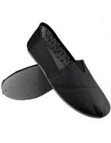](http://www.google.com.au/imgres?q=canvas+slip-ons+shoes+ballet+slippers+school+girls&um=1&hl=en&safe=active&tbo=d&biw=1311&bih=564&tbm=isch&tbnid=v6LiH21XAtMzOM:&imgrefurl=http://www.amazon.co.uk/Ballet-Pumps-Flats-Men-Shoes/s?ie=UTF8&page=1&rh=n:362382011,p_n_target_audience_browse-bin:363841011&docid=sSPXSC1QR7INiM&imgurl=http://ecx.images-amazon.com/images/I/41gskrFd2iL._SL500_SX190_CR0,0,190,246_.jpg&w=190&h=246&ei=dRu0UKPeNa-XiAfW9ICgAw&zoom=1&iact=hc&vpx=4&vpy=176&dur=4205&hovh=196&hovw=152&tx=121&ty=129&sig=100718891362253927631&page=2&tbnh=169&tbnw=131&start=33&ndsp=21&ved=1t:429,r:0,s:33,i:189)[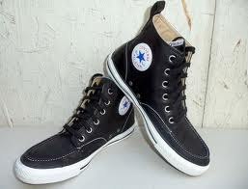](http://www.google.com.au/imgres?q=black+leather+school+shoes&start=311&um=1&hl=en&safe=active&sa=N&tbo=d&biw=1311&bih=564&tbm=isch&tbnid=Qfso-W-m_Xr63M:&imgrefurl=http://myconverseshoes.blog.com/&docid=RET_YUpxwNAwhM&imgurl=http://myconverseshoes.blog.com/files/2011/02/black_leather_sneakers_converse_all_star_chuck_taylor.jpg&w=479&h=367&ei=XhS0UMf2HOPZigfyw4GQAw&zoom=1&iact=hc&vpx=536&vpy=232&dur=2409&hovh=196&hovw=257&tx=182&ty=158&sig=100718891362253927631&page=17&tbnh=164&tbnw=231&ndsp=18&ved=1t:429,r:15,s:311,i:114)[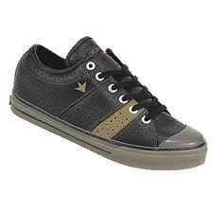](http://www.google.com.au/imgres?q=black+leather+school+shoes&start=829&um=1&hl=en&safe=active&biw=1366&bih=587&tbm=isch&tbnid=ZUyR2J1t4ouKcM:&imgrefurl=http://www.birdfight.com/deuce-black-brown-perforated-leather-dekline-shoe/&docid=e5mmqZ6usKzyMM&imgurl=http://www.birdfight.com/blogfiles/wp-content/uploads/2007/03/m_088_dekline.jpg&w=400&h=400&ei=RQmrUKfYF4eimQXPvYAg&zoom=1&iact=hc&vpx=332&vpy=134&dur=858&hovh=225&hovw=225&tx=141&ty=135&sig=100718891362253927631&page=30&tbnh=129&tbnw=128&ndsp=31&ved=1t:429,r:25,s:829,i:262)[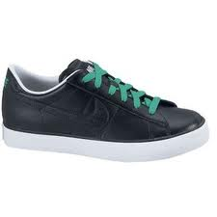](http://www.google.com.au/imgres?q=black+leather+school+shoes&start=347&um=1&hl=en&safe=active&sa=N&tbo=d&biw=1311&bih=564&tbm=isch&tbnid=w7nHgDcl5_PV7M:&imgrefurl=http://www.polyvore.com/nike_sweet_classic_leather_low/thing?id=59748206&docid=WMYJRhD762-rFM&imgurl=http://www.polyvore.com/cgi/img-thing?.out=jpg&size=l&tid=59748206&w=300&h=300&ei=XhS0UMf2HOPZigfyw4GQAw&zoom=1&iact=rc&dur=2&sig=100718891362253927631&page=19&tbnh=160&tbnw=203&ndsp=20&ved=1t:429,r:10,s:347,i:214&tx=139&ty=110)[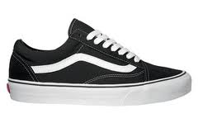](http://www.google.com.au/imgres?q=black+school+shoes&start=306&um=1&hl=en&safe=active&sa=N&biw=1366&bih=587&tbm=isch&tbnid=xJ6sFBA-k-jqXM:&imgrefurl=http://www.ebay.com.au/itm/Vans-Old-Skool-Trainers-Black-White-Old-School-Shoes-/270635276181&docid=xTaSfy_AYvwbdM&imgurl=http://i.ebayimg.com/00/s/MzIyWDUzOQ==/$(KGrHqJ,!jgE95Brlv5,BPs8qQIjwg~~60_35.JPG&w=300&h=179&ei=KgerUJ3DPLD0mAW3sYGIDg&zoom=1&iact=hc&vpx=782&vpy=298&dur=3089&hovh=143&hovw=240&tx=182&ty=95&sig=100718891362253927631&page=12&tbnh=122&tbnw=205&ndsp=28&ved=1t:429,r:12,s:306,i:132)

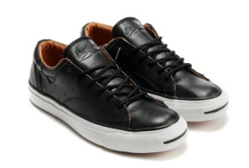

[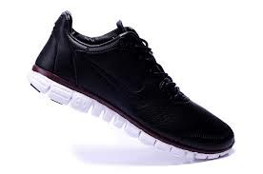](http://www.google.com.au/imgres?q=black+leather+shoes&um=1&hl=en&safe=active&tbo=d&biw=1311&bih=564&tbm=isch&tbnid=-w0aTxMx_o8N_M:&imgrefurl=http://www.nikerunshoes.org/nike-free-30-v4-mens-2012-leather-shoes-black-p-618.html&docid=Oo_RrgUOFkX5aM&imgurl=http://www.nikerunshoes.org/images/2012/10/28/Nike%20Free%203.0%20V4%20Mens%202012%20Leather%20Shoes%20Black_2.jpg&w=750&h=498&ei=khW0UI7nBcPliAfu2IC4Aw&zoom=1&iact=hc&vpx=692&vpy=180&dur=1277&hovh=183&hovw=276&tx=141&ty=115&sig=100718891362253927631&page=4&tbnh=124&tbnw=186&start=65&ndsp=19&ved=1t:429,r:4,s:65,i:305)[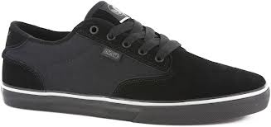](http://www.google.com.au/imgres?q=black+school+shoes&start=222&um=1&hl=en&safe=active&sa=N&biw=1366&bih=587&tbm=isch&tbnid=E0elaAPJTU35qM:&imgrefurl=http://www.tactics.com/dvs/daewon-12er-skate-shoes/black-to-school&docid=4ADYAm4Gvvbp8M&imgurl=http://www.tactics.com/a/4wx9/9/dvs-daewon-12er-skate-shoes-black-to-school.jpg&w=1500&h=709&ei=-AarUKyoIuuJmwXgx4GwDg&zoom=1&iact=hc&vpx=674&vpy=313&dur=1030&hovh=154&hovw=327&tx=209&ty=101&sig=100718891362253927631&page=9&tbnh=77&tbnw=162&ndsp=28&ved=1t:429,r:25,s:222,i:173)[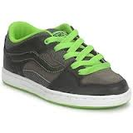](http://www.google.com.au/imgres?q=black+leather+school+shoes&start=140&um=1&hl=en&safe=active&sa=N&tbo=d&biw=1311&bih=564&tbm=isch&tbnid=sHtj2wLyJSL1cM:&imgrefurl=http://www.ciao.co.uk/Fashion_Accessories_5302023_2-type-shoes,fashion_for-children,brand-vans&docid=DcKmfFQKSuG0VM&imgurl=http://uk-can1.ciao.com/can_uk/12215098574.jpg&w=200&h=200&ei=pxO0UMzAOqnYigeT6oDYAw&zoom=1&iact=hc&vpx=897&vpy=268&dur=1378&hovh=160&hovw=160&tx=101&ty=106&sig=100718891362253927631&page=8&tbnh=157&tbnw=157&ndsp=20&ved=1t:429,r:18,s:140,i:242)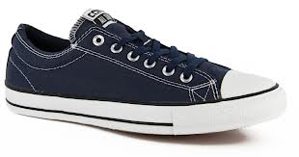[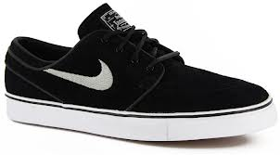](http://www.google.com.au/imgres?q=black+shoes&um=1&hl=en&safe=active&tbo=d&biw=1311&bih=564&tbm=isch&tbnid=P46LPscTlnPk0M:&imgrefurl=http://www.tactics.com/nike-sb/zoom-stefan-janoski-sb-skate-shoes/black-black&docid=ZiuTdkWsl7kmSM&imgurl=http://www.tactics.com/a/4iza/9/nike-sb-zoom-stefan-janoski-sb-skate-shoes-black.jpg&w=1448&h=801&ei=Vxa0UN_7HKieiAeX3YCwAw&zoom=1&iact=hc&vpx=963&vpy=137&dur=1271&hovh=167&hovw=302&tx=181&ty=63&sig=100718891362253927631&page=3&tbnh=126&tbnw=228&start=46&ndsp=20&ved=1t:429,r:19,s:46,i:291)[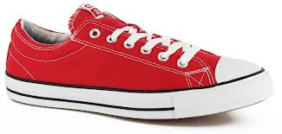](http://www.google.com.au/imgres?q=shoes+converse+red&um=1&hl=en&safe=active&tbo=d&biw=1311&bih=564&tbm=isch&tbnid=9G8dlWFIEu2bXM:&imgrefurl=http://www.tactics.com/converse/cons-cts-skate-shoes/red-white&docid=QyyecOuYmVCulM&imgurl=http://www.tactics.com/a/4ljp/9/converse-cons-cts-skate-shoes-red-white.jpg&w=1500&h=717&ei=wxm0UIv6L4yRiQea4oGwAw&zoom=1&iact=hc&vpx=2&vpy=274&dur=770&hovh=155&hovw=325&tx=119&ty=108&sig=100718891362253927631&page=1&tbnh=70&tbnw=147&start=0&ndsp=27&ved=1t:429,r:9,s:0,i:111)

🗶

🗶